When and where is the 3rd International Conference of the Society for Medical Anthropology?

The conference will take place on March 9-12, 2010 in Havana, Cuba, in collaboration with the University of Havana. The venue is the Havana Convention Center.

Is travel to Cuba to attend a professional meeting authorized for US citizens and US residents?

Travel to Cuba for US citizens and those who live in the US of any citizenship is regulated by the US Department of the Treasury. You can check the most updated information here. As of November 2019, “professional research and professional meetings” is one of the categories of activities authorized by general license. Additional information can be found here and here. If you plan to bring family members, please make sure that you comply with US regulations by checking those websites or contacting US authorities. The SMA cannot provide legal information.

What type of Cuban visa do I need to travel to Cuba?

The University of Havana has confirmed that a tourist visa is all that is needed to attend the conference. You can purchase your visa online or at some of the airports that fly to Havana. You can find more information with your airline or here. US citizens and residents may travel to Cuba legally but ONLY during the days of the conference or any other authorized activity. We suggest that US citizens and residents who attend the conference retain conference materials in the unlikely event that they are needed when returning through US immigration. Please find additional information at the Consular Information Sheet for Cuba and the CDC’s Health Information for Travelers to Cuba.

What currency do I use in Cuba?

There are two types of currency in Cuba, both called the peso. The regular Cuban peso (=USD$0.05) is referred to as moneda nacional or pesos cubanos and identified on signs as MN. The Cuban Convertible Peso or CUC must be used almost everywhere. It is legal to bring U.S. dollars, euros, or other foreign currencies into the country and to hold them, but you cannot actually spend anything except CUC currently and, where allowed, MN. Money should be changed at official exchange houses known as cadecas, which can be found at hotels and other locations. The exchange rate is exactly the same at each cadeca ($1.00 = 0.87 CUC), although the airport may offer different rates during the weekend. US credit cards cannot be used in Cuba. You will need to bring cash to convert to CUC to pay all your expenses in Cuba.

Are there any hotels offering special rates?

Two hotels are offering special rates to attend the conference (see additional documents):
- The Hotel Palco, located adjacent to the Havana Convention Center.
- The International Health Center La Pradera, which provides transportation to the Havana Convention Center for a fee.

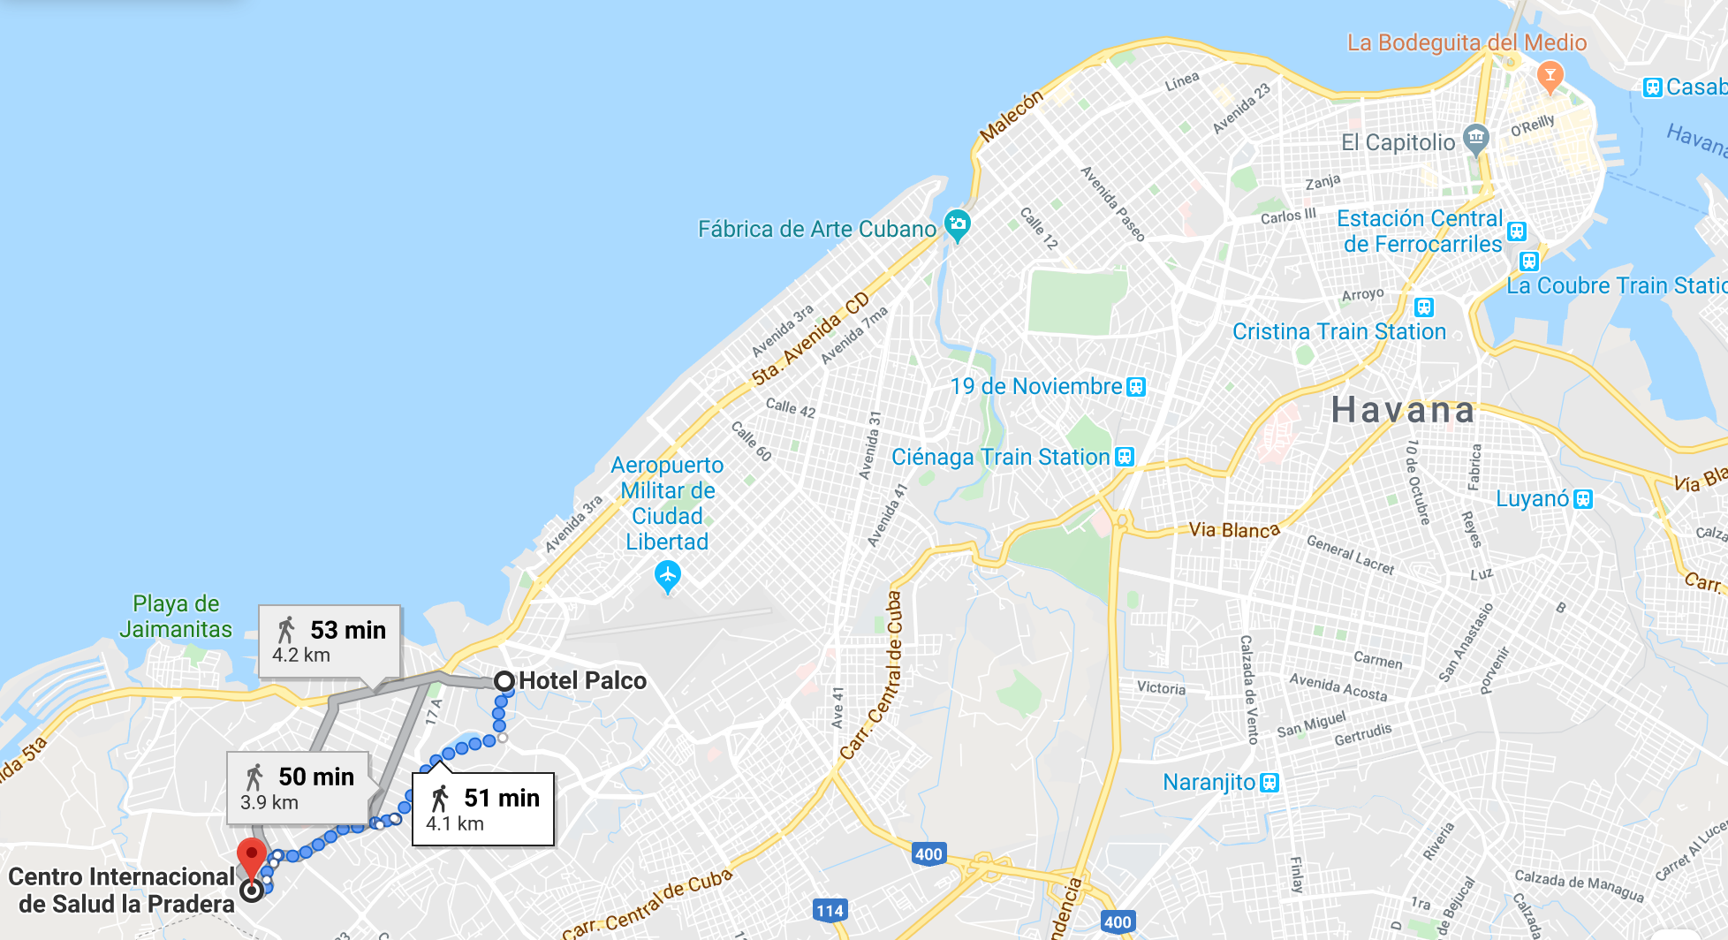

You are free to book your accommodations in other hotels or through short term rentals. US citizens and residents need to follow US regulations for booking accommodations.
Please note that the SMA cannot assist with accommodation or travel bookings.
Can conference registration be paid onsite or in advance online only?

You can pay the registration online by contacting cobroonlinepalacio2@palco.cu (although several participants have experienced delays in obtaining a response), through this link https://www.eventospalco.com/es/contact-us/contacts/palacioconvenciones, or by contacting Tamara González at tamara@palco.cu. You can also call Narai Carvajal at +53-7-208-5609‬. If you pay online, the Havana Convention Center will charge 250 euros. If you pay onsite, you will pay 250 CUC (which is slightly less than 250 euros as of the rates in November 2020).

Please note that the SMA does not collect any registration fees and cannot assist during the registration process beyond providing the contact information. If you experience delays, please be patient. Office hours in Cuba may be limited due to energy restrictions. You can always pay onsite.

Will I have access to the internet while in Cuba?

US cell phones may work in Cuba but roaming can soon become very expensive. Please check your company for rates. There are several outdoor Wi-Fi hotspots all over Havana, but you still need to purchase internet cards to access the service. These cards can be purchased at ETECSA offices and at some hotels. You can find more information here.

Will I be able to learn about the Cuban health system during my visit?

Some conference participants have expressed interest in learning about the Cuban health system. If you’re interested in visiting health facilities on Monday, March 9th and/or Friday, March 13th, please fill this short questionnaire. Your availability and email address will be provided to MEDICC, a non-profit organization that promotes US-Cuba health collaboration and highlights Cuba’s public health approaches to inform the quest for health equity and universal health worldwide. The SMA will not be involved in these visits. For any additional information, please contact MEDICC’s Elizabeth Sayre.

When will my presentation take place?

The program conference will be posted here. Please check for updates. If the information that you’re looking for is not yet posted, it means that we’re still finalizing the program. Thanks for your patience.

What is the language of the SMA 2020 Conference?

The conference will be held in Spanish and English. Every presenter will present in the language they chose when they submitted their proposal. All the plenary presentations and some of the parallel sessions will count with translation services; other parallel sessions will take place in either Spanish or English. Any updates to the conference program will be posted here.

Please note that any information provided here is subject to change.

