SMA Webmaster Report: November 1, 2017 to November 4, 2018
Sydney Yeager, Ph.D. Student, Southern Methodist University
November 4, 2018

Website Analytics

Visitors
Visitors to the SMA website increased in comparison to the previous year.
- 42,911 Users (1.9% decrease from previous year)
- 52,978 Sessions (5.1% decrease from previous year)
- 76,182 Page Views (11% decrease from previous year)

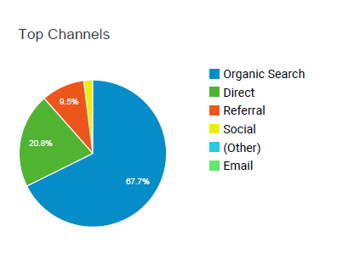

67.7% of visitors find SMA through an organic search utilizing a search engine, which indicates that our pages are easily accessible through search metrics. 20.8% of our visitors access the site directly, these are most likely SMA members and return users who directly type in our site address.

Top Referrals
9.5% of our visitors come to us through links for other sites.
Our top four referral sites are:
- americananthro.org
- somatosphere.net
- medanthroquarterly.org
- en.wikipedia.org

Only 2% of our traffic comes from our social media accounts. This is an issue worth investigating as a way to improve our overall traffic. 437 users came to our site from twitter, a more than 200% increase from last years referral of 212 users from twitter. This improvement may be linked to the integration of SMA’s twitter account and its announcement posts. This year 398 users were referred from Facebook a 9.4% drop.

Global Visitors
Nearly every country visited the SMA website (though many may be bots that automatically search sites). The majority of visitors come from the U.S., Canada, India, United Kingdom, and South Africa. English remains the primary language used to access our site with 0.94% of users translating the site into Spanish, 0.38% of users translating it into simplified Chinese, and 0.30% translating the site into German.

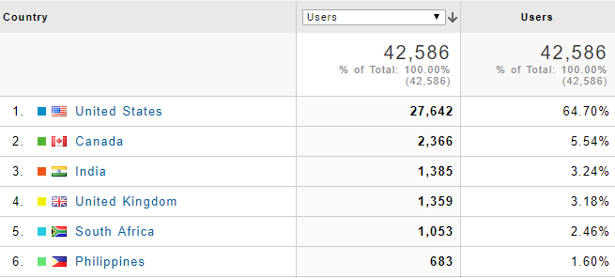

Demographics of Visitors
Most visitors to the website are younger than 35, with 45% of visitors in the 18-24 age range and 28% in the 25 to 34 age range. 68.5% visitors to the website are female.

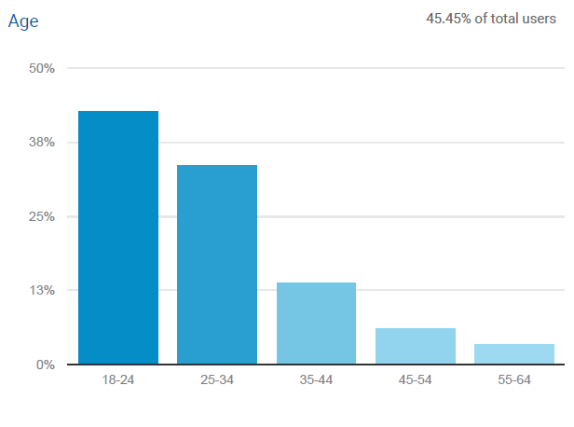

Most Visited Pages
The most visited pages are “About Medical Anthropology”, the home page, interest groups page and the jobs announcement category:

Rank | Page | Number of Visitors
1 | /about/about-medical-anthropology/ | 32, 496 (42.65%)
2 | Home Page | 10,267 (13.48%)
3 | /about/ | 2,090 (2.74%)
4 | /interest-groups/ | 1,729 (2.27%)
5 | /category/jobs/ | 1,564 (2.05%)
6 | /about/sma-awards/ | 1,064 (1.40%)
7 | /academic-resources/guidelines-for-an-accessible-presentation/ | 965 (1.27%)
8 | /about/sma-awards/aaa-conference-student-travel-awards/ | 800 (1.05%)
9 | /policy/prior-statements/global-health/ | 798 (1.05%)

Key Activities

Website Hosting and Design
SMA’s website is hosted on the American Anthropological Association servers. AAA now oversees all “back-end” technical aspects including security and site backup. However, Vernon Horn who oversaw these changes in 2017 is no longer with the AAA. In Vernon’s absence, the AAA web hosting proved problematic. It meant that the SMA site and the SIG sites had difficulty with site updates and maintenance for several months. This situation has now been resolved with the hiring of Shawn Ifill in September.

A more contemporary, user-friendly and low-cost design was implemented in 2017. The new design includes links to our social media platforms (Facebook, Twitter) and an enhanced search function. Yet this increased integration has not increased the site’s traffic flow from social media sites. Further collaboration between the webmaster and social media manager will be necessary to improve this issue for the upcoming year.

The current template does not allow for easy modification to highlight SIG posts, as was anticipated in the 2016 report. Solutions to improve these issues of integration will be an important focus for the upcoming months.

Job posts are consistently a big draw of traffic to the SMA site. These posts include a logo and key term tags in addition to text to improve their SEO (search machine optimization).

Funding opportunities, workshops, and medical anthropology graduate programs are now being included in the site's announcements posts as well.

Decreases in Users, Sessions, and Page Views
The most significant drops in user acquisition relate to organic searches and referrals from other sites. Traffic from organic searches dropped by approximately 2,000 users. Finding ways to improve the search machine optimization of our pages and announcement posts is likely the best strategy to increase our traffic flow from organic searches.

Our referrals were also down by over 2,000 users. Referrals from the AAA site dropped by 1,400 users. The Wiley site was our second and fourth largest referrer last and this year it did not even make the top ten. I do not know why this is, perhaps this traffic redirected to the MAQ site. The issue of referrals is harder to address, but branding is a factor.

Fundraising Efforts
In tandem with fundraising efforts in 2017, a donation page was added to SMA and includes both a direct donation to AAA-SMA link, as well as a link to the Amazon Affiliate program. The Amazon Affiliate program provides a small referral payment when visitors make a purchase on Amazon.com after clicking through our referral link. After a year of enrollment in this program, it has been very unsuccessful. We have yet to reach the threshold for a payout.

Recommendations for 2017-2018

- Add content for younger visitors: As indicated by the demographic and technology analytics, it appears as though a younger demographic is visiting SMA.

- Design New Logo: Logo design contest is in the works.

- Highlight Jobs, SIG, Policy, and Conference Pages: visitors are increasingly viewing job postings, information on SIGs, policy briefs, and conference-related posts and pages. It may be worthwhile to further enhance these pages in our various media platforms.

- Academic Resources: Revive the SMA syllabus and bibliography resources page

- New Book Announcements: Consider promoting the announcement of new books by SMA members with SMA’s Amazon affiliates referral link and any discount codes for people interested in purchasing the book. These type of announcements already take place over the SMA list serv but the website announcement reaches a wider and younger audience.

- Membership Page: Design an informational page describing how to join SMA through the AAA and the perks of membership. Currently, our join button links directly to the AAA membership page without an explanation of why.

- SMA Platform Integration: Work with AAA to develop a technological solution to increase site integration between SMA site and SIG sites, either using a RSS feed widget or an alternative solution. I have already reached out to Shawn Ifill, the AAA web admin, to discuss this issue.

- Medical Anthropology Video: Erin recommended creating a What is medical anthropology? video to add to our about page. I think this would be a great. I will be asking SMA members to share a brief clip giving their answers to this question through the website’s announcements and our social media channels.

- Amazon Affiliates: Thus far the SMA is not earning money through the Amazon affiliates program. If this is a priority for the upcoming year, then I recommend including referral links to the Amazon affiliates page on any pages or announcement which include book titles such as syllabi, bibliographies, book announcements.

