2015 Webmaster Report: November 13, 2014 to October 13, 2015
Society for Medical Anthropology (SMA)
Submitted by Sean Bruna, PhD., SMA Webmaster on October 16, 2015

SMA Hosted Websites, Site Design and Server

Hosted Websites

The SMA hosts 11 distinct websites, each with a distinct architecture, design, and user base.
- SMA: Society for Medical Anthropology
- AARG: AIDS and Anthropology Research Group
- ADTSG: Alcohol, Drug, and Tobacco Study Group
- AMHIG: Anthropology and Mental Health Interest Group
- CAGH: Critical Anthropology for Global Health Study Group
- CAM/IM: Complementary and Alternative Medicine (CAM) & Integrative Medicine (IM)
- CAR: Council on Anthropology and Reproduction
- DRIG: Disability Research Interest Group
- MASA: Medical Anthropology Students Association
- STM: Science, Technology, and Medicine Group
- Program Directory: Medical Anthropology Program Directory

In addition to Medanthro.net, the primary site for the Society, SMA also owns Medanthro.org and Medanthro.net, both of which redirect visitors to our primary site.

Visitors to SMA are encouraged to contact the SMA Webmaster via email at webmaster@medanthro.net if they encounter issues with the website or wish to make changes.

SMA Design
In 2013 the SMA Website was moved from an HTML designed site to a dynamic WordPress site that supports browsing on desktop and mobile platforms. In 2015, at the request of the AAA webmaster, the AAA logo was added to the SMA homepage.

The SMA website currently composed of 70 pages and 217 blog posts. Many of the pages on the SMA site are not visited or are outdated. Revising or deleting pages will improve how the site is used along with site speed.

SMA Server
In the previous year SMA was given free non-profit hosting on Dreamhost. The Webmaster is rebuilding and testing the architecture for the SMA websites. Site speed appears to have increased from our current load time of 5-10 seconds to 3 seconds. The final move will occur in mid December, when schools are on their winter break.

Website Analytics

Number of Visitors
We are tracking site utilization with Google analytics and this report addresses site usage from November 13, 2014 to October 13, 2015.

The SMA website had slightly more visitors in the 2014-2015 than in the year prior.
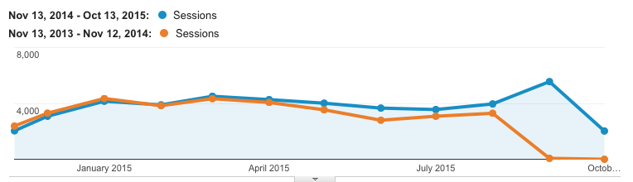

From November 13, 2014 to October 13, 2015 (the date of the report) monthly sessions increased slightly to 4,000-5,500 visits per month for a total of 44,745 sessions by 33,842 users during the 2014-2015 period.

Location of Visitors
Visitors to SMA come from nearly every county, though most visitors are from the United States, Canada and the United Kingdom.

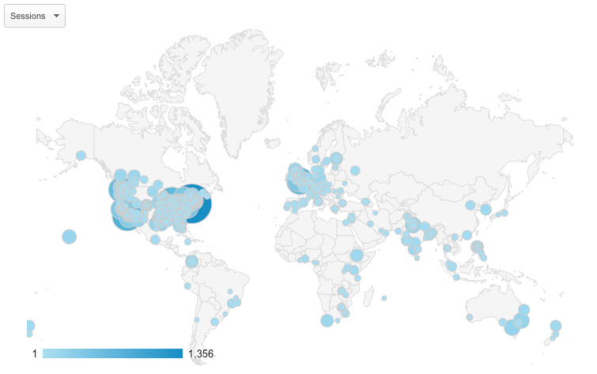

The top ten countries visiting SMA are:
Country Number of Sessions (percent of total)
United States 27,620 (62.01%)
Canada 2,480 (5.57%)
United Kingdom 2,334 (5.24%)
India 1,184(2.66%)
Australia 653 (1.47%)
Germany 553 (1.24%)
South Africa 513 (1.15%)
Philippines 509 (1.14%)
Netherlands 400 (0.90%)
Brazil 366 (0.82%)

Age and Gender of Visitors
SMA only began tracking age and gender this year and information is not yet available.

Top 10 Visited Pages
There were 77,286 page views to SMA. The top ten pages were:

Page Rank | Page Title | Page views (% of total)
1 | Society for Medical Anthropology (Home Page) | 18,487 (23.92%)
2 | What is Medical Anthropology, Anyway? | 8,250 (10.67%)
3 | Jobs | 5,149 (6.66%)
4 | Page not found | 3,323 (4.30%)
5 | For Authors (MAQ Information Page) | 1,824 (2.36%)
6 | SMA Global Directory | 1,625 (2.10%)
7 | Newsletter | 1,256 (1.63%)
8 | Europe | 1,201 (1.55%)
9 | About | 1,085 (1.40%)
10 | Executive Board | 982 (1.27%

Top 10 Visited Pages
More viewers are using the site from their mobile phones, though desktop browsers are the preferred method for viewing the site.
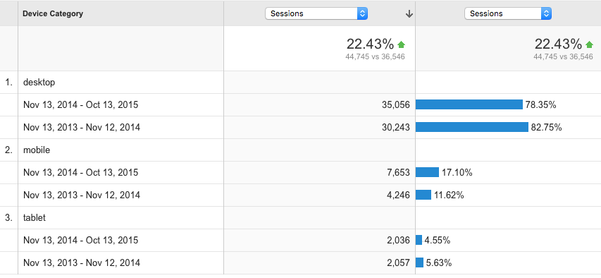

Site Engagement
Individuals are spending slightly more time on our site when compared to last year. However, most visitors still spend only 0-10 seconds before leaving.

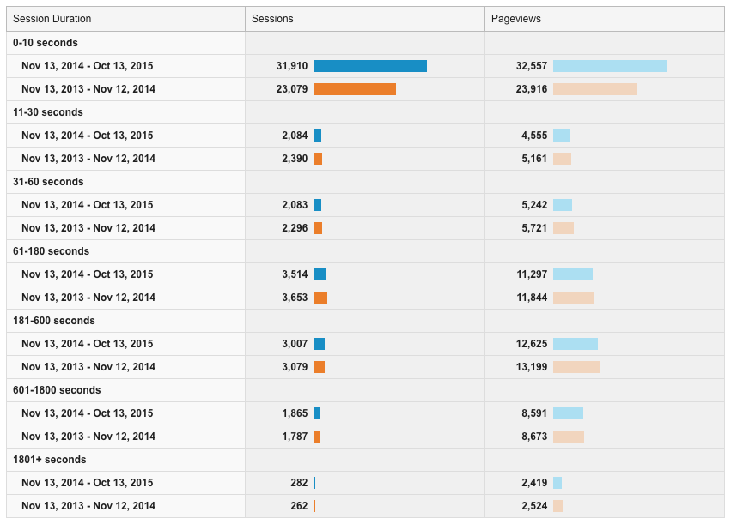

Special SMA Pages

Blog
We continue to post material on the SMA blog, one of the more popular tools of our site. Most visitors visit the blog looking for jobs. In the previous year we posted approximately 40 job listings.

Global Directory
Updates to the Global Directory are listed in the 2014-2015 SMA Global Directory Committee Report.

Program Directory
The Program directly is experiencing many of the same issues as the previous version of the Global Directory: (1) The program running the site is outdated and cannot be easily updated. (2) The directory is run on a separate domain and does not share the same branding as the current SMA website. (3) Medanthro programs are unable to update their listing on the directory.

Recommendations for Future Development of Medanthro.net
Visits to Medanthro.net continue to grow. In the previous three years visitation expanded from 500 visits per month to nearly 5,000. The following four issues require board action:

- Fully Move To New Host – Finalizing the move of all of our sites in an organized manner may require some downtime. The sites will be moved in December during winter break (Dec 14-16, expected) and it is possible, but not anticipated, that all SMA websites will be unavailable.

- Prelaunch Program Directory – Given site security issues, inability of medanthro programs to update their information, and incongruences in branding, I recommend re-launching the program directory under committee guidance.

- Add SMA Authors Page – Several users have asked for SMA to add a SMA Author page. I recommend posting award-winning authors under guides from a committee.

- Review SMA Webpages – Many of the pages on the SMA site are not used or are outdated and could use either revision or deletion. Under guidance of a committee, the Webmaster would like to update or delete these pages.

